1 Mbit/s BPSK L-band modulator / demodulator

Transmitter configuration
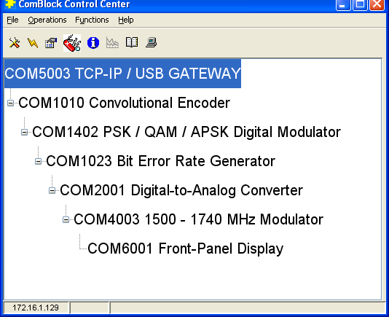

1 Mbit/s, BPSK, 1500 MHz, external 10 MHz reference clock
Convolutional FEC encoding, K=7, R=1/2
1-bit serial HDLC framing.
IP address 172.16.1.129

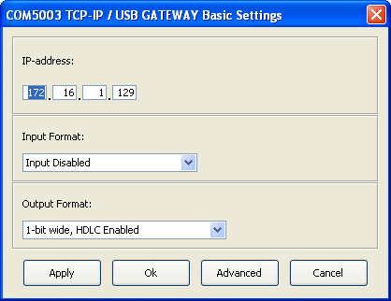

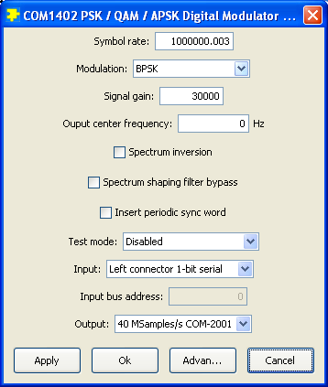

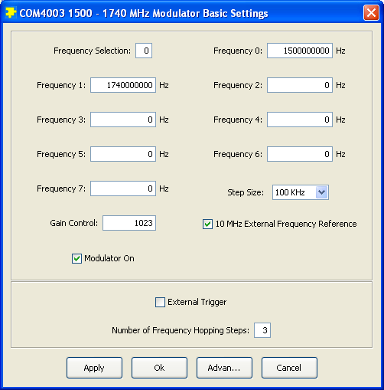
Receiver configuration
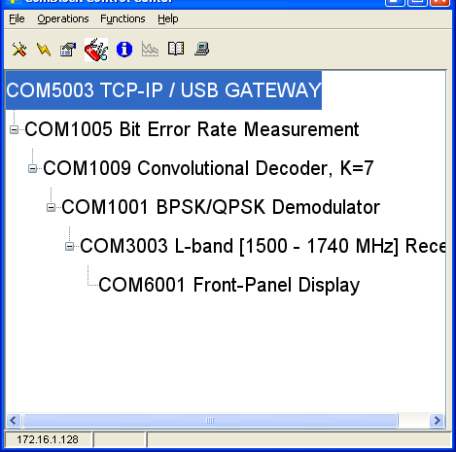
1 Mbit/s, BPSK, 1500 MHz, external 10 MHz reference clock
Convolutional FEC decoding, K=7, R=1/2
1-bit serial HDLC framing.
IP address 172.16.1.128

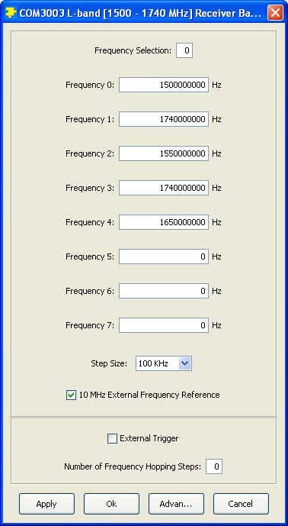

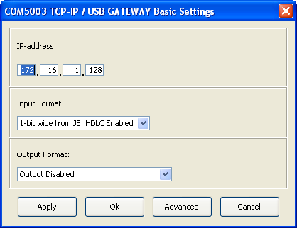

BER measurement shows 0 errors in 1,000,000 decoded bits after FEC decoding (when COM-1010 REG1=08)
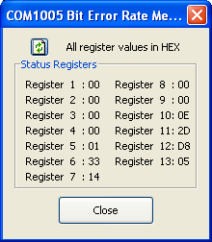
REG5(0) = 1 indicates BER synchronization with the PRBS-11 sequence transmitted by the COM-1010 in test mode. REG1/2/3/4 indicate no bit errors.

Using two hyperterminal windows, sending text from end to end
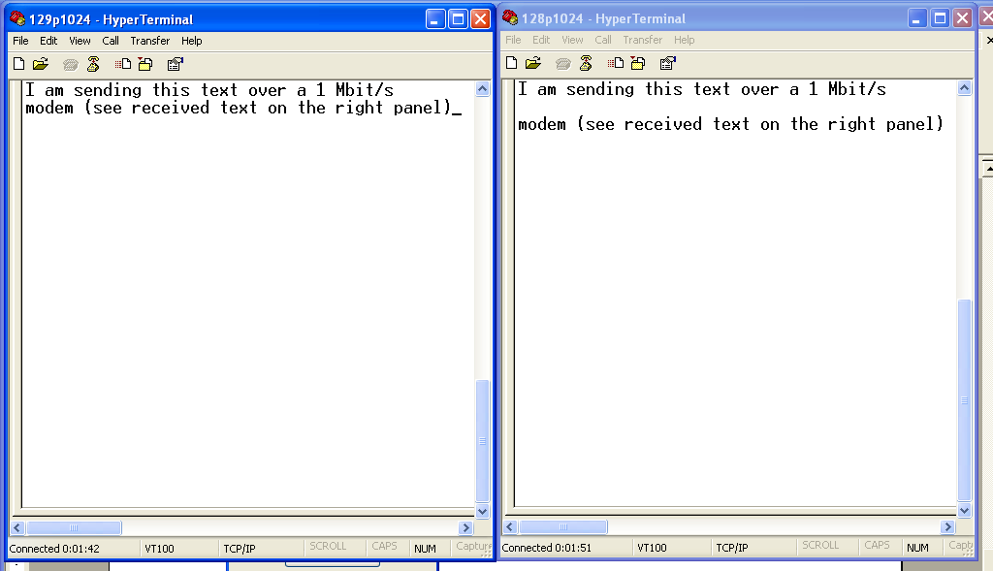

Hyperterminal configuration
